P.M.L. S.D. PUBLIC SCHOOL
SECTOR 32-C, CHANDIGARH

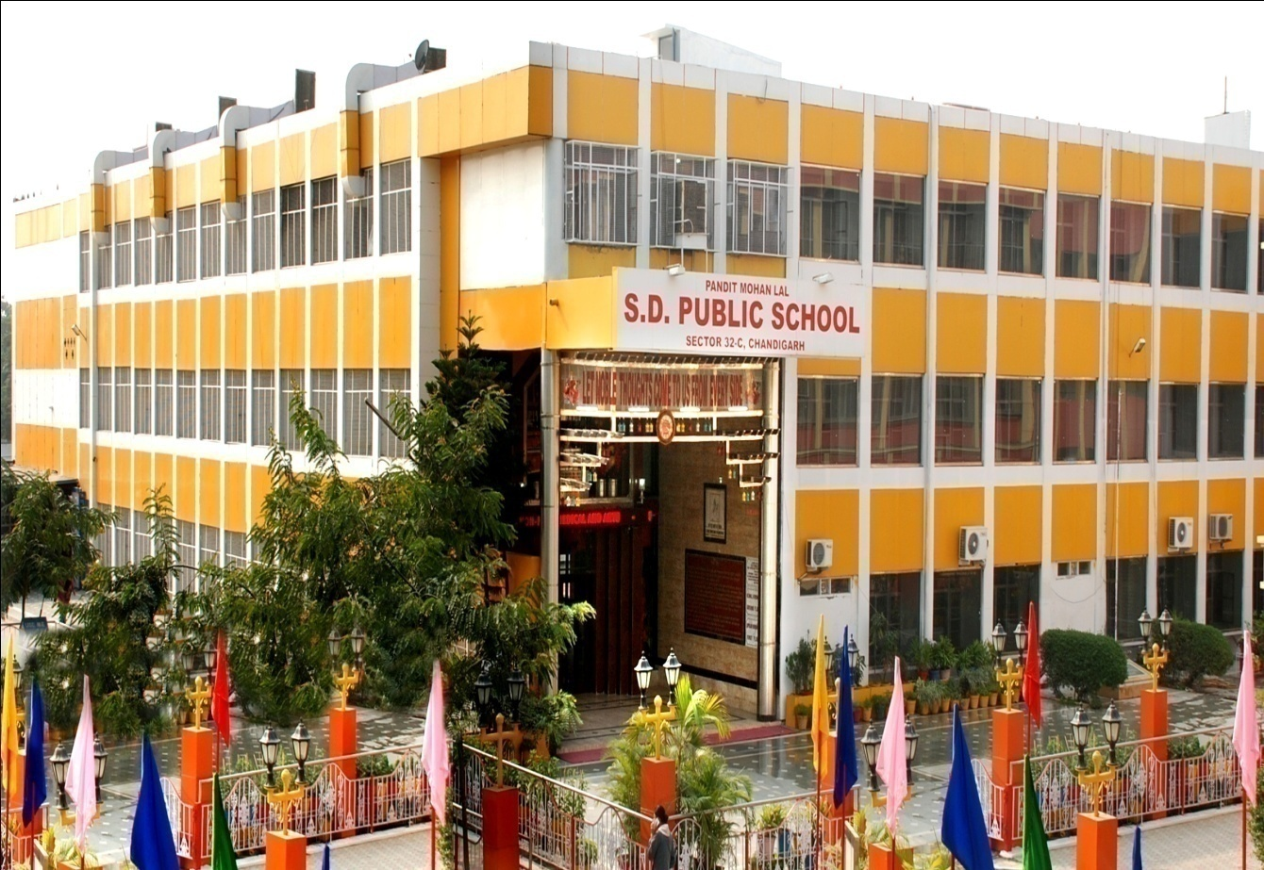

PROGRESS REPORT
(Session 2022 – 2023)
Sept 24,2022

A very good morning to one and all

Results:

It is a matter of great pride to announce that we secured 100% result in XII Commerce and Class X CBSE board examination in the session 2021-2022 with 18 students getting 95% and above and 62 students with 90% and above. Etching the magnanimous feat in the unending saga of success, TANISH CHAWLA with 98.2% is the proud topper from class 12th Commerce and Sanchit Gupta with 94% marks in class 10th.

Students graduating from the school system are expected to be equipped with complex skills, competencies and ability to solve real life problems, innovate, communicate effectively, be resilient in times of adversities and demonstrate grit and determination and so on….
Therefore, the purpose of Inter and Intra School activities and competitions is to build up overall confident personality of a student.

Inter School Activities:
- An Inter School Activity on the topic ‘Best out of waste’ for the six schools under our hub created by CBSE was organized on 11th May, 2022 in the school campus. A total of 52 students and 6 teachers participated in the activity. The students were divided into three categories according to classes i.e. 3rd to 5th, 6th to 8th and 9th to10th. A special workshop for the teachers was also held. Adhering to the theme, the students were judged on the basis of their creativity/ability and the use of Eco-friendly resources.
- Ritik Sahni and Raghav of class XII won first prize in Codeathon organised by KBDAV school chd on 29th July. The students from tricity, Haryana Punjab and Delhi participated in the event.
- Our school student Sugun Sabharwal of class XII-A2 Commerce participated in I.I.M.U.M i.e. India's International Movement to Unite Nations and earned the Special Mention award. This organization is a youth organization comprising of 26000 young organizers from the age of 14-22. It empowers the youth by enabling them to solve global problems at an individual level.
- Qbiz was organized by Fraser Valley University at SD College, Sector 32, Chandigarh. Rehaan Goyal bagged 1st position and Kanav Goyal earned 2nd position.
Intra School Activities:
- Baisakhi was celebrated with great pomp and show. Children were attired beautifully in Punjabi Costumes and were apprised about their culture and folklore.
- Students of classes II to V were guided – How to wash hands using proper 5 steps so that their hands are properly and effectively sanitized.
- A Debate Competition was held for class XII students on 30th April, 2022. A total of 18 students participated. Vikhyat bagged first position.
- On Mothers Day Activity, Students creatively crafted Paper Flowers, Photo frames and Greeting Cards presenting their special bonds with their mothers.
- Investiture Ceremony for Primary and Senior Secondary wing 2022-23 was held on 19th May, 2022. It is a solemn occasion when the young students are prepared to don the mantle of leadership and discharge the responsibilities entrusted upon them by the school. The ceremony concluded with the new council of students all set to embark on the new journey.
- 15 days Yoga Mahotsav was also celebrated by all students to keep them fit and healthy wherein various activities were organized sensitizing students about healthy physical and eating habits.
- A Dental Check-up for the students of all classes was conducted Dr. Ravi Kumar- BDS, MDS (Periodontology, Oral Implantology) and his team from Vital Dental, Multi-Specialty Cosmetic; Implant Centre, Sector-15A, Chd. visited the school. The dental check-up went on for 3 days and the team of doctors examined the students class wise.
- A visit to Botanical Garden in our premises for grade-3 to 5. Students were shown variety of plants and trees planted there and they were explained about the benefits of planting trees. They enthusiastically replied about various queries asked about roots, stems and parts of the plants.
- Rainy season’s Rain Walk was organized for the tiny tots of “PETALS”. The little ones brought colourful umbrellas and raincoats for their fun activity. The purpose of the drive was to inculcate good habits in children right from their basic years. The tiny tots were told that various hygiene factors like steps to hand washing, brushing, dipping of nails and the importance of taking a bath daily.
- Various activities were organized on campus to celebrate Teej which include Rangoli making, Mehandi, best out of waste and poster making. Students actively participated in all the activities. Prizes were given to the students who performed exceptionally.
- We believe in holistic growth of the students. Games and Sports are an equally important aspect in overall development of students. Keeping in view that Intra Mural Badminton Tournament was organised in the school campus in the month of July and August for classes IX to XII in both categories of boys and girls. The students were super enthusiastic and they showed a wholesome sportsman spirit during the tournament. Trophies were awarded to the winners.
- Every month an activity is dedicated to one particular field to draw a practical approach towards it. Last month i.e. July was dedicated to Commerce related activities. The students of all streams participated in “Ad Mad World” competition. The students were required to create original innovative advertisements using suitable props. Before that in the month of May, English Week was celebrated from Nursery to Class XII.
- School organized a workshop for the students of class XII on the topic “Communication & Entrepreneurship – Skill Courage”. Mr. Rajeev Markanday, the author of various books on competitive exams, a trainer and a person with a great sense of humour was the speaker of the day. More than 150 students very enthusiastically participated.
- The school celebrated the 76th Independence Day with great patriotic fervor. There was an array of cultural events where the students participated very enthusiastically. The festivities of the day began by unfurling of the National Flag. To mark this special day, there were various events like speeches, poem recitation & melodies patriotic songs and nukkad natak.
- This time too, on 18th August, 2022, following the yearly tradition, the auspicious Janamashtami Pujan was organized in the school premises. Bhajan devoted to Lord Krishna were Sung and fruits were distributed among all the students and staff members. The tiny tots came traditionally dressed as Radha and Krishna. It was of splendid sight to behold.
- Fire & Evacuation drills are organized to sensitize, felicitate & train staff/teachers and students to test response plan to evacuation and revise it for further improvement. A mock drill was conducted by the Fire Station Officer, Sector 32C, Chandigarh on 24th August, 2022. About 250 students participated in the seminar cum drill. The students learned about using the fire extinguishers and were educated about evacuation technique to put in during emergency like fire, earthquake etc.
- On 25th August, 2022, Dr. Bobby Gulati, Addl. Project Director, State Aids Control Society, Chandigarh presented an information talk related to blood disorders – Hemophilia and Thalassemia to class 10th students. The students were made aware of the symptoms, issues related to the above given disorders and the various treatments available. The students were also apprised about the government aid available for the treatment of such patients.
- The school paid a tribute to Shri Pandit Mohan Lal Ji (Ex. Home Finance & Education Minister of Punjab) the founder of the institute on his 23rd death anniversary by performing a Havan on 30th August, 2022 in the school premises. The Chairman-cum-Director – Mr. K. K. Sharma (PCS, Retd.), school Principal, other members of the Managing Committee, teachers and students all gathered to pay tribute to the great visionary. Shri Pandit Mohan Lal Ji left for his heavenly abode on 30th August, 1999 and since then every year a Havan is organized as a mark of respect and honour. Bhajans were also recited and the whole atmosphere was grateful to the divine soul.
- Teacher’s Day was celebrated with great enthusiasm in our premises. Students decorated their respective classrooms and accorded a grand welcome to their teachers. As per the guidelines issued by the Ministry of Education to celebrate Shikshak Parv, some senior students were designated to become teacher for the rest of the classes. The student teachers who received the best feedback from the children in the classroom were given certificates of recognition. Students organized cake cutting ceremonies with their respective teachers and clicked photographs with them. To add more colours to the celebration a culture programme was organized by students, wherein various games were organized for the teachers and they conveyed their feelings through speeches. Keeping in view the health & well being of the mentors a talk was delivered by Dr. Manjeet Singh Trehan, Director Medicine from FORTIS Med Center, Sector 11, Chd. To end it on a memorable note, gifts were distributed to the staff by honourable Chairman Sir.

Life Skills Activities:
- Continuing with our quest for creating a culture of innovation in the school, we have created “Buddy Groups” in each section from class III to XII to provide intellectual stimulation by bringing together group of students and teachers of diverse interests, subject knowledge and skill sets to work together.

- To inculcate values and life skills by embedding mentoring groups called “Goodness Ambassadors” have been created have been created, wherein one social value or life skill is picked up as theme of the month engaging students of all classes in various activities such as PPT presentations, role plays etc. to explore, understand, improve and strengthen.

Sports Achievements:
- Ankit of class 12th added another feather in the cap of achievements by winning gold medal by defeating Services team in Khelo India Khelo Youth Boxing Championship. Ashish Hooda won silver medal in the same event which were held from 4th June to 13th June.
- In 5th Youth Women’s National Boxing Championship which was held from 5th July to 11th July at Chennai, Tamil Nadu, Pranjal Yadav clinched gold and Parineeta won bronze medal. Pranjal got selected for Golden Gloves International Tournament to be held in next week. She will also represent India in World Championship to be held in November 2022. Harsh also won gold in Nationals and qualified for Asian Champinship.
- Ranveer Duggal of 12th Arts is going to participate in World Snooker Youth Championship which was held at Romania from 26 August, 2022.
- Harleen Purewal of class XII-B Arts from our school got two gold in under 17 age group (Discuss throw and shot put) in Chandigarh State Sub Junior and Junior Championships held at Sector 7, sports Complex on 19.08.2022 to 21.08.2022.
- Vanshika of Class XI-Arts got one gold in 100 mtrs. and bronze medal in 300 meters in Chandigarh State Sub Junior and Junior Championships held at Sector 7, Sports Complex from19.08.2022 to 21.08.2022.
- Students yet again proved their excellence in sports and games genre . The students bagged three medals in 38th Chandigarh State Yogasan Sports Championship. Kritika Mishra secured Gold medal, Paritosh Jain secured silver and Rashi secured Bronze. A total of five students are selected for National Championship.
- Indian Youth Women Boxing Team going to participate in Golden Gloves International Tournament to be held in Serbia from 13th September to 18th September. PRANJAL YADAV of Class 12 Arts is participating in this tournament.
- Naksh of class IX won gold medal and Rashi and Sristhi won bronze medal each in Yogasana Competition held in Panchkula. They have been selected to represent Chandigarh in 36th National Games 2022 to be held in Gujrat.
NSS Activities:
- We celebrated World Earth Day in the school premises. The function was inaugurated by Principal and Shri Kuldeep Mehra (founder Mehra environment and Art foundation, Chandigarh). Rudraksh plants were planted in the school campus by them along with the school NSS volunteers.
- Shri Kuldeep Mehra, in his speech, gave a brief background of World Environmental Day on June 5 and also shared this year’s theme which is -Invest in our Planet. He also added that this theme encourages everyone to come together and devote their time and energy in safeguarding the environment.
- NSS wing organized a special programme on 30th April, 2022 to honour the class IV employees for their tireless/endless efforts on the special occasion of May Day. 1st May is celebrated as May Day to appreciate the efforts of these people who work day and night for the smooth functioning of the nation. A small cultural programme was also presented to mark this day. The NSS volunteers of the school organized varied events to express their gratitude towards them such as musical chair, lecture for the class IV employees. The students of primary wing of the school presented them with small gifts as a token of love and respect for them.
- The School celebrated World Population Day which falls on 11th July, 2022. The students of NSS unit of the school presented a Nukkad Natak to create awareness on the issue of growing population. The Nukkad Natak focused on the ill effects of rapid growth of population on the development of economy.
- Har Ghar Tiranga rally was organized by the students around Sector 32 which was flagged off by Dr. Nemi Chand Golia, State Liasion officer (NSS Cell) Chandigarh on the occasion of Azadi Ka Amrit Mohotsav. Plantation drive also done by Shri Nemi Chand Golia.

Seminars and Workshops:
- The school hosted a Capacity Building Workshop on Happy Classrooms organized by CBSE on 1 st July, 2022. Ms. Anupma Sharma a renowned resource person and retired principal, DAV Solan, shared her worthy insights with participants. A total of 52 participants from various schools of the tricity were there. It was an interactive and informative session. The workshop emphasized on the healthy student teacher relationship.
- Principal and Teachers attended many more webinars and training workshops in an offline as well as online mode organized by CBSE and Chandigarh Administration.
- The school held a sensitization programme on Financial Literacy and Use of Digital Tools organized by CBSE on 25th July, 2022. 117 Principals and teachers from the hub schools attended this session which was extremely informative and interactive. His valuable insights and observations provided all educators useful tips for financial planning growth. Mr. Nikhil Kathuria, an eminent CA was the spokesperson for the training session.
Admissions:
As per CBSE norms, Teacher student ratio is 1: 40 in each section. So, Commerce stream has 6 sections, Arts and Science has 2 sections each. The student’s strength is full and complete. No further admissions are allowed now.

The collective effort of leaders, dedicated staff, enthusiastic students and Parents helps us to maintain high school standards and to achieve rigorous learning goals.

Thank you.

