P.M.L. S.D. PUBLIC SCHOOL
SECTOR 32-C, CHANDIGARH

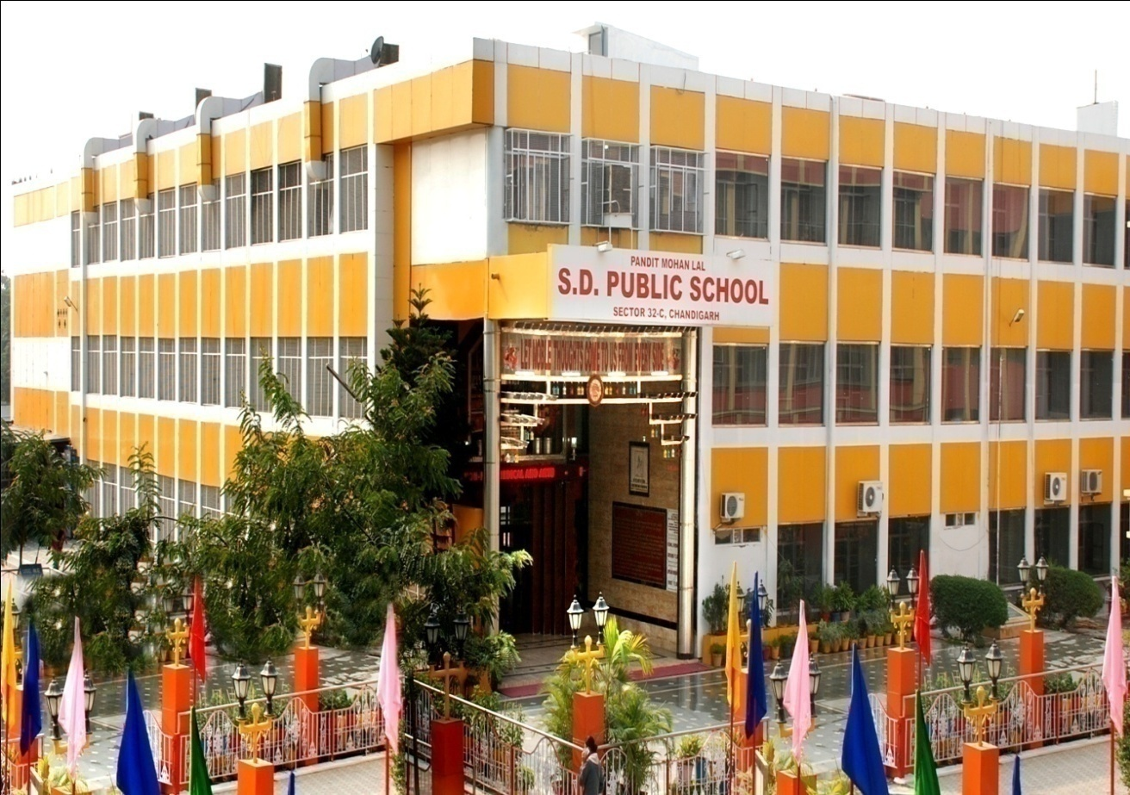
PROGRESS REPORT
(Session 2025 – 2026)

Sept. 27, 2025

Respected Chairman Sir, worthy members of the Managing Committee, representatives from the staff.

A very good morning to one and all

Results:
It is a matter of great pride to announce that we secured 100% result in XII in all streams and Class X CBSE board examination in the session 2024-2025 with 8 students getting 95% and above and 45 students with 90% and above.

Awards & Appreciations:
- CBSE has selected STEM Education as central theme for teachers’ training deliberations among teachers from various schools across India. For fostering professional growth and collaboration, a STEM DLD Event was held on 26th July, 2025 at St. Kabir Public School, Chandigarh wherein two teachers from our school, Mrs Bharti Arora and Mrs. Ruchika Vashisht participated and presented their case study based papers on STEM. Out of which Mrs Ruchika Vashisht’s case study paper got selected for National level presentation.
- On the occasion of Teachers' Day, Ms. Anshu was honored for her exceptional contributions to education. The appreciation award for ‘Best Tutor and Best Future 'was presented by the Sarvahara Education Welfare Association by the chief guest Shri Gulab Chand Kataria (Governor of Punjab and administration of chandigarh) on 5th September at the Punjab University 'Law Auditorium'.
- Ms. Rajni Kanwar was honored by Rotary Club Chandigarh for the contributions as an educator. This esteemed acknowledgment affirmed her commitment to fostering learning and inspiring students. It further strengthens her dedication to advancing education and shaping young minds.

Students graduating from the school system are expected to be equipped with complex skills, competencies and ability to solve real life problems, innovate, communicate effectively, be resilient in times of adversities and demonstrate grit and determination and gets a well rounded experience that prepares them for life beyond school.
Therefore, the purpose of Inter and Intra School activities and competitions is to build up overall confident personality of a student.
Inter School Activities:
- RIPPLES'09 conducted by DAV School, Sector 15 had plethora of activities and various exciting events such as - Poetry Recitation, Quiz, Star Chef Cooking Competition, Screen Master , Fancy Dress, Scientific Temperament, Folk Song, Folk Dance, Book Wizard, Poster presentation, etc. All the participants exhibited exceptional Skills. Ritesh (X) and Yashika (XII) were delared winners in Quiz and Consolation Prize was won by Amaira (I) in Fancy Dress Competition.
- The students of our school showcased their literary brilliance at the prestigious M.R.A. Litreture Festival winning 1st Prize in the “ Story Weavers” competition and 3rd Prize in the “ Popcorn Prophecies ” competition.
- At Young Founders Summit, Chandigarh. A three-day event which brought together top young minds from across the country to pitch groundbreaking startup ideas. Their teams stood out for their innovation and impact, earning praise from judges and mentors alike. Nidhi Rana, along with her team members, has won the prestigious Young Founders Summit, securing a cash prize of Rs. 50,000. Afreena Narang, with the support of her team, has won third position, winning a cash prize of Rs. 25,000. Garima Kushwaha won a special mention award.
- Nidhi Rana was awarded Best Delegate in the United Nations General Assembly (UNGA) at MRAMUN 2025. Her performance was a master class in negotiation, leadership; her contributions shaped the flow of the committee and left a lasting impact on delegates and judges alike.
- Navishtha Bahl, a student of Class XI (Science), was honoured with a Certificate of Appreciation and a memento in recognition of her commendable contribution as Head of Department – Registrations in the Organizing Committee of MRAMUN 2025. She efficiently streamlined the registration process and provided valuable assistance to delegates in completing their registrations for the various allotted committees, thereby ensuring the smooth execution of the event.
- We are delighted to share that our students took part in the inter school competition “Celebrating 78 Years of Freedom – From Heritage towards Development” organised by Kundan International school in collaboration with splash media and emerged as winners in Dance Competition and bagged 2nd position in Poster Making Competition. 1st Prize for Best Concept and Message was also bagged by our student Riya of class VIII.
Intra School Activities:
Right kind of exposure at the right time is important for students to develop 21st century skills as Emphasized by NEP 2020, to create globally future ready citizens.
- In effort to incorporate healthy eating habits in the students “POSHAN MAH” was executed in the month of April, 2025 for students of classes I to VIII. With various meaningful and practical activities.
- In a vibrant celebration of Earth Day a series of eco-friendly and thought-provoking activities, aimed at raising awareness about environmental conservation and sustainable living were organized in and beyond the boundaries of the school.
- The month of April was very engaging for the students of Classes VI – X in the books. The Library has a good array of Authors and their best selling works of Fiction. The whole purpose of this meaningful activity is that they understand the purpose of a Biography and Author's Profile. The students can identify personal details of Authors.
- To cultivate a supportive environment for young individuals to explore their creativity and expression, a wide array of activities were conducted to commemorate the occasion of World Book Day. The students showcased their talent and Creativity in all the spheres. Classes VI - VIII made beautiful Bookmarks using eco-friendly material. Meaningful Slogans were also penned down. Classes IX, X were made to write about famous Authors. They learnt about the Style of writing and also how an author's background influences their writing style.
- Anti Drug Campaign, a social initiative commenced with installation of a symbolic ‘TREE OF LIFE’ in the school premises aimed at raising awareness about the dangers of drug addiction.
- In a hands-on science activity aimed at promoting Fire Safety and Awareness, students successfully created models of simple fire extinguishers using common household materials. The initiative combined practical science learning with real-world applications, helping students understand the importance of fire prevention and control.
- The school echoed with pride and promise as it held its annual Investiture Ceremony on 1st May for the Senior and junior wing marking the formal induction of the newly elected student council for the academic session 2025-26.
- No. of competitions were organized for secondary and senior sec. class students to hone their public speaking skills and to instill self belief and a positive mindset, such as debate, declamations, Best out of waste, Rhetoric speeches, quizzes etc.
- Various activities are organized on every Saturday which has been declared as “No Bag Day” by CBSE to develop various competencies & skills like critical thinking, Foundational Literacy & Numeracy, creativity and above all teamwork and confidence to strive and thrive in this rapidly changing world. Such as fruit day, colours day, Rain walk, Nature walk, Show and tell competitions, Poetry recitations, fancy dress activities, Kathputli shows, Magic show, Helpers day and many more. Awareness sessions involving personal and public hygiene, anti-social activities are also held regularly by vertical buddy groups in the class.
- Various days like martyrdom day of shaheed Udham Singh, Teej, Independence day, Janmashtami, Earth day, Water Conservation Day, and many more were celebrated organizing various activities, competitions, special assemblies, exposure visits etc.
- The school organized a Fresher’s party for students of class XI. The programme was organized to promote bonding and create memorable experiences that mark the beginning of their new phase of life, important for realizing their aspirations.

Life Skills Activities:
Pearls of Ethics our life skill club organize theme based events to develop the relevant life skill so that children are ethically sound, socially responsible and innovative thinkers engaging all students from Nursery to class XII in various activities and competitions like Chart making, Ted talks, storytelling, PPTs, role plays etc. Every month has a different theme based on ethics and values.
In addition to the ongoing AI classes, Robotics has also been introduced for Classes I to VIII. Through this program, students will gain an understanding of how the Quarky robot works and how it can be controlled using the coding platform PictoBlox.

Sports Achievements:
- Our talented boxer Prachi Khatri of Class 12, represented INDIA and secured a bronze medal in the International Training Camp-cum-Competition 2025, held in XINJIANG, CHINA from 15th to 30th August 2025. Her hard work, discipline, and dedication have brought glory to the school and the Nation.
- In Inter School Boxing Championship 2025 held on 12th Sept. in Chandigarh, the outstanding performance of our students brought 19 medals win with 11 gold, 2 silver and 6 bronze medals. Our school has proudly won the Overall Championship in Under-17 Boys, Under-17 Girls and Under-19 Boys.
- I am extremely proud to announce that our three talented boxers represented the school on 14th Sep, 2025 in the CBSE NATIONAL BOXING CHAMPIONSHIP 2025 and brought glory with their outstanding performances. Anshika Dabas, Ishika and Mukul Dabas all three won gold medals and emerged as CHAMPIONS in their respective categories.
- Our champions Harsh won Gold, Anshika Dabas and Nidhi Dhull both with Silver medal showcased their incredible boxing talent at the Khelo India Youth Games, held in Bihar. For the very first time, Chandigarh boxers reached the finals of Khelo India — and all three finalists were from our school.
- Our talented students have made us proud at the Junior Nationals 2025 – Prachi Khatri won gold medal, Ishika and Jeenat both won bronze medal at the event.
- The student of school won medals in the Mahatma Gandhi Kompte Games held from 12th - 14th April, 2025 at sports complex Sector -7, Chandigarh. 1st position was bagged by Shivam under 12 boys in Javelin Throw event.
- Our school student Aryan Makkar brought laurel by winning Gold Under-19 in the Chandigarh State Badminton Championship 2025 held at Sector 38 West Complex, Chandigarh from on 20th to 23rd Aug, 2025.
- On 27th Aug, our Under-17 Boys Badminton Team has won the Overall Championship in the Inter-School Badminton Tournament. Our boys played with great skill, determination, and team spirit, defeating last year’s champions to bring home this prestigious title.
- The Students of the school Won Medals in the 6th State Yogasana Championship Games held from 24th August to 26th August 2025 at Yoga Education College, Sector 23, Chandigarh. Students won 4 Gold, 3 Silver and 3 bronze medals in Traditional Yogasana, Artistic yogasana, Rhythmic Yogasana.
- The school takes immense pride in announcing that our talented student, Nikhil Nandal, has achieved a remarkable feat on 8th Sep, 2025 by winning the Gold Medal in the Sub-Junior State Kayaking and Canoeing Championship. In recognition of his outstanding performance and dedication to sports, Nikhil was honoured at Tagore Theatre, Chandigarh, where the Honourable Governor of Punjab and Administrator of Chandigarh, Shri Gulab Chand Kataria, presented him with a cash award of ₹48,000.
- The school organised CBSE Cluster XVII Basketball Tournament under-19 (Boys & Girls) in Aug, 2025 wherein, more than 90 teams and around 1080 participants from Punjab and Chandigarh participated to prove their mettle as the young and energetic players of Basketball.
- The school inaugurated an 24th Pandit Mohan Lal Memorial Basketball Tournament and 5th Pandit Mohan Lal Memorial Boxing Tournament (U 19 Boys and Girls) in the memory of its revered Founder Pandit Mohan Lal Sharma on 29th August 2025 with solemn respect and dignity. The champions of both the tournaments were felicitated with medals, certificates, and cash prizes of Rs.1.5 lacs. The atmosphere was vibrant as the young players received applause for their determination and talent.
- Akshiv Dangwal of class V won a gold medal in the 3rd Punjab State High Kick Taekwondo Championship held at LPU on 16th and 17th August.
- Our students won 1 gold, silver and bronze medal each in 41st Chandigarh State Yoga Sports Championship held at Dev Samaj College for Women, Sector 45-B, Chandigarh on 30th August, 2025.
- In Inter School Taekwondo Championship, Nimish and Ujjwal secured third position in the event.

NSS Activities:
- The Interact Club of School and NSS proudly organized a noble initiative — a Blood Donation Camp titled “Jeevan Dhara” — in our campus, reinforcing the school’s deep commitment to social responsibility and community welfare.
- On 17th April 2025, the 120th Birth Anniversary of Late Sh. Pandit Mohan Lal Ji, former Home and Finance Minister, Punjab the founder of the school was celebrated with great devotion and fervor by the Management, Principal, staff and students of the school. The langar was organised in association with Mata Mansa Devi temple, stationed outside GMCH, Sector 32, Chd. and the langar was distributed by the NSS volunteers and staff members of the school. The event lasted for ten consecutive days.
- The school organized a special programme to honour the class IV employees for their tireless/endless efforts on 1st May, celebrated as Labor Day to appreciate the efforts of these people who work day and night for the smooth functioning of the nation.
- The students of the school enthusiastically took part in a mega event, Walk for Drug Free Chandigarh at Tiranga Park, Sector 17, Chandigarh to spread awareness among students and curb the drug menace.
- International Yoga Day was celebrated on 21st June. NSS volunteers and the students of classes VI to IX participated enthusiastically.
- To mark the celebration of Tree Plantation week (Van Mahotsav) under the theme एक पेड़ मां के नाम , the NSS volunteers of the school conducted a tree plantation drive on 7th July 2025 wherein many saplings were planted in the school premises.
Seminars and Workshops:
- A powerful and inspiring workshop titled “I Can – Motivational Session” was conducted by Narayana Educational Institute for students of Classes IX and X on 2nd May. The session focused on instilling self-belief and a positive mindset among students by emphasizing the power of the phrase “I Can.”
- The students of class XI and XII participated in a Career and professional Guidance session, with regard to pursuing education in overseas educational institutions, conducted by EDWISE ( India's leading overseas education consultants) on 6th May 2025 at Hyatt centric Sector 17 Chandigarh.
- A very meaningful and insightful Career Guidance session was organised for the students of Classes IX and X on 7th May at the Mini - Auditorium of the School, in collaboration with the Silver Fern Consultants, our career guidance partners. The Students were given extensive guidance about an array of career choices.
- On 24th July, The Birds and Bees Talk (TBBT) – Growing Up Life Skills Session was conducted in school premises by Faarika Mehta (District Lead), Nandini Thakur (Volunteer) and organized by PLAN International and MASH Project Foundation. The seminar aimed to educate students about peer pressure as part of the Growing Up Life Skills module under "The Birds and Bees Talk (TBBT)" program for the students of class IX to XII.
- The Rotary Youth Leadership Awards (RYLA) in collaboration with Rotary Club, Chandigarh was conducted on 29th July, 2025. It was an inspiring day focused on growth and self-discovery under the theme “Solivagant”—finding strength in walking your own path. Rotarian Rajender Kaur, Vice President of Rotary Club Chandigarh presided over the function, along with many other Rotarians. RYLA 2025 was more than an event—it was a journey of transformation.
- Our Rotary Youth Exchange candidate, Hitesh from Class XII, participated in a Cultural Youth Exchange Program in Germany from 13th to 17th July. The visit proved to be a valuable and engaging experience, marked by insightful interactions and cultural exchange.
- On 20th August 2025, a Shark Tank Workshop was conducted. The event was organized by The Times of India in collaboration with Top Rankers Saurabh Jaiswal, Founder Director and CAT Trainer. An accomplished motivational speaker, his philosophical insights on life's pressing problems for Youth find relevance with today's generation and was specially designed for the students of Class XII.
- The students of the Humanities stream class XI and XII conducted a workshop on Quality Education and Inclusivity on 21st August, 2025 as part of the program, they presented a meaningful skit titled “A Seat for Everyone”, which highlighted the value of giving equal opportunities to all. They also recited a heart-touching poem on the importance of inclusive education, emphasizing acceptance and togetherness.
- Our school organized a Menstrual Hygiene Awareness Activity for senior students. The activity was an interactive talk by the teacher and volunteer girls.
- Innovation Activity, featuring videos sent by CBSE, was successfully conducted on 28th August 2025 for Class XI students. The activity was aimed to encourage students towards innovation and provided valuable insights into creative thinking and problem-solving.
Teachers are attending various Capacity bundling programs in their respective subjects both online and offline.
- As part of Nutrition Week Celebration, Ms. Sangeeta Vidyarthi and Ms. Shashi Sharma attended a workshop conducted by Mr. Mohit Nijhawan, Founder & CEO of Greenu and Dr. Sonia from the Nutrition Department, Fortis Hospital.
- A Capacity Building Workshop on English Core for Classes XI & XII was organized by the Central Board of Secondary Education (CBSE) on 22nd and 23rd August 2025. The workshop aimed at equipping teachers with innovative strategies and effective methodologies for enhancing language skills and competency-based learning in senior secondary classes.
- 2 days Capacity Building Programme for Science, Physics, English, Business Studies were being attended by respective subject teachers in various schools of Chandigarh. These workshops are conducted by CBSE to train teachers as per NEP 2020.
- 1 day Capacity Building Programme for generic topics like Happy classrooms, Active learning in classrooms, Gender Sensitivity and Use of AI in classrooms are also being attended by many teachers.
- Mr. Jayant and Ms. Bharti Arora are the Resource Persons for the subject of Physical Education, Health and Wellness, Computer Science, AI, IT etc. respectively and conducted CBSE workshops as Resource persons in various schools.

Admissions:
This session we completed our total strength of 280 students in class XI as allowed as per the By Laws of CBSE.
With the collective effort of leaders, dedicated staff and enthusiastic students, we have been and will always try and give our best incorporating the guidelines of NEP 2020 and NCF bringing in the new technology advancement and holistic learning.
For this I express my gratitude to Chairman Sir and all worthy members.

Thank you.

